***Neural Style Transfer***

**Image – 1 Image – 2**

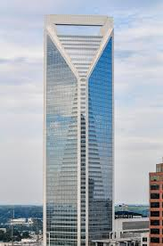 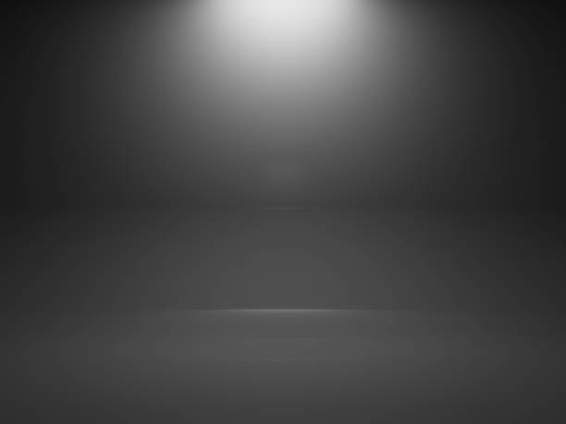



Deep Net

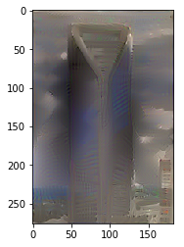

**Image - 3 Final o/p**